Project 1: Creating Your Ideal 21st Century Classroom

University of Southern Mississippi
ITD 645
Dr. Shuyan Wang
June 20, 2021

Authors:
Sarah Holder
Carletta S. Hurt
Kimberly Jefferson
Michaelah Martin
Elijah Morgan

Executive Summary
It is no secret that technology is advancing and progressing every single day. With the advancement of technology comes an advancement in education. It is imperative that teachers are creating an environment that reflects these changes and adaptations to our technological world. The purpose of this proposal is to request a grant for $20,000 to provide ample classroom equipment and technologies that can enhance each student’s educational experience and foster a technologically advanced classroom. The classroom itself comes with the following items:
- 28 student desks
- A teacher desk & chair
- A teacher work station (which is used as a space for one-on-one remediation time)
- 4 desktop computers & chairs (which essentially is a space for printing documents)
- One laser printer (connected to the 4 working desktops)
- Two group tables with 4 chairs each (for rotating science labs/activities for small groups)
- One bookcase for classroom sets of books
- One 4-drawer filing cabinet for teacher essentials
- One full-size white board for supplemental instruction and reminders
- One full size bulletin board for posting reminders and other information to the classes.
These items listed are essential to any classroom space, and still serve an integral purpose to the modern classroom, which itself is intrinsically technology based. The goal of this is to build upon these foundational items in the traditional classroom, and allow technology to “fill” the gaps of educational need, and further scaffold in technology to this space and, therefore, streamlining the educational experience. As listed, all items included in the class are essential, and can serve a variety of necessary functions in the classroom, whether it be students working independently at their desks with their Chromebooks, on a small group lab experiment that is stationed at one of the group tables, or printing research and assignments from the desktop/printer station.
The 21st century has produced several technological tools that aid in the educational experience of students and teachers. Our ideal classroom is one that reflects these 21st century updates, providing a safe, creative, and innovative space for all types of learners. Receiving this grant would guarantee us the resources to provide this space and continue to aid in the success of each student.
By receiving this grant, it would provide the teachers and the students with alternative work spaces to enhance focus and creativity, one-to-one electronic devices to be used for research, storage to create an organized and structured environment, and several online resources to enhance learning experiences. After extensive research, meetings, and collaboration, a list was created of all vital tools that would be necessary to create the ideal 21st century classroom. Below is a list of the equipment and technologies needed to make this possible:
- Charging Stations
- Cubbies
- Metal Storage Racks
- SmartBoard
- Chromebooks/Tables
- Headphones
- VR Headsets
- Google Classroom
- Dictation Software
- Loom Software
- MicMute
- Seeing Al
- Natural Reader App
- Virtual Frog Dissection Software
- ShareCareVR

This list provides a variety of items, all ingrained in the world of technological learning such as the students’ personal computers (the Chromebooks) and the Virtual Reality (VR) headsets. These VR headsets, and headphones if needed by the student, will allow them to experience new levels of educational experiences never before done in a STEM classroom setting, and can easily be worked into a rotational lab experiment, where small groups of 5 can interact at the “VR Station” for a lab. Additionally, headphones give the classroom the versatility to become quiet spaces for individualized learning experiences. Purchasing the headphones in packs of ten allows each student access to their own pair of headphones with two pairs to spare for the classroom.
In conclusion, we are certain these requests will provide students with the best 21st century learning experience possible and aid them in succeeding both in school and beyond their education. Our goal is to provide the best possible educational experience to all of our students. We hope you will consider our request to help see this goal through.
Purchases & Rationale
Item | Quantity | Price | Source | Rationale
Charging stations for each table | 7 | $27.99 (x7)= $195.93 | Amazon | Provides the ability to keep devices conveniently powered and ensure the class maintains technological capability. Power hubs are conveniently positioned on the tables to allow students to power devices while seated and enjoy uninterrupted engagement with all technologically-based learning. These charging stations will be connected to a power source from one of the wall-outlets via a power strip and extension cords.
Cubbies | 1 | $149.99 | Amazon | The cubbies provide a sleek and functional solution for the clutter and disorganization which inevitably accompany learning materials and supplies.
Metal Storage Rack | 2 | $75.00 | Target | Provides additional storage solutions for larger items that do not fit inside cubbies.
SmartBoard | 1 | $3,825.00 | Touch Boards | The SmartBoard Touch Board can facilitate an optimized learning experience for the students by allowing them to interactively engage with the learning materials on a large scale. The Touch boards are large enough for many students to simultaneously view and interact with the learning activities presented. The touch boards are highly effective at augmenting the learning experiences for kinesthetic and visual learners.
Chromebooks | 28 | 499 (x28)= $13,972.00 | Google | Provides the student with a means to complete virtually-based work, assignments, and activities. Facilitates the administrative processes (e.g. word processing, file storage, etc.) required for student lesson plans.
Headphones | 30 | $74.99 per pack of 10 (x3) = 224.97 | Amazon | Provides optimal learning when students need to focus, minimize distractions, and isolate the source of information (engaged listening for those students that need headphone assistance via their IEP file).
Oculus VR Headset | 5 | $299.00 (x5)= $1,495.00 | Oculus | The VR headsets host virtual reality learning programs which afford students the opportunity to experience learning to a very unique depth. Virtual Reality simulations allow the kinesthetic and visual learner to experience and participate in the learnings through their own eyes and awareness. VR can greatly augment the learning experiences by maximizing student engagement.
Google Classroom/Suite | 1 | Free | Google | Provides students and teachers the ability to interact and facilitate the classroom activities virtually. Google Classroom serves as a hub that houses the administrative teacher/student tasks.
Dictation Software | 1 | Free | Learning Tools | The text-to-speech functionality serves as a resource for students with poor writing or typing skills, poor grammar skills, or disabilities.
Loom | 28 | Free | Loom | Provides a way for students and teachers to interact and communicate virtually.
MicMute | 1 | Free | Source Forge | Microphone management tool
Seeing Al | 1 | Free | Apple Application Store | An AI-driven technology for the visually impaired that presents sound descriptions of surroundings. The program helps visually impaired students see the world around them through sound.
Natural Reader Application | 1 | Free | Natural Readers | Provides a resource for students who have difficulty reading, have dyslexia or are visually impaired. The program is capable of reading/narrating material in several different languages with the option of choosing different voices.
VR Frog Dissection | 1 5 | $11.99 (x5) = $59.95 | Oculus | VR Program which provides students with the opportunity to actively participate in the dissection of a frog virtually. The program provides step-by-step instructions and includes all of the materials and learning experience without all the mess.
Science Zone | 5 | FREE | Google Play | Exploratory learning for students to extend classroom learning and increasing science knowledge base
ShareCare VR | 5 | FREE | Oculus | Provides access to other science-based lessons which will reinforce the skills presented in the lesson plan.
TOTAL: $19,997.84

Classroom Design(s) and Configurations
Figure 1 & 2:
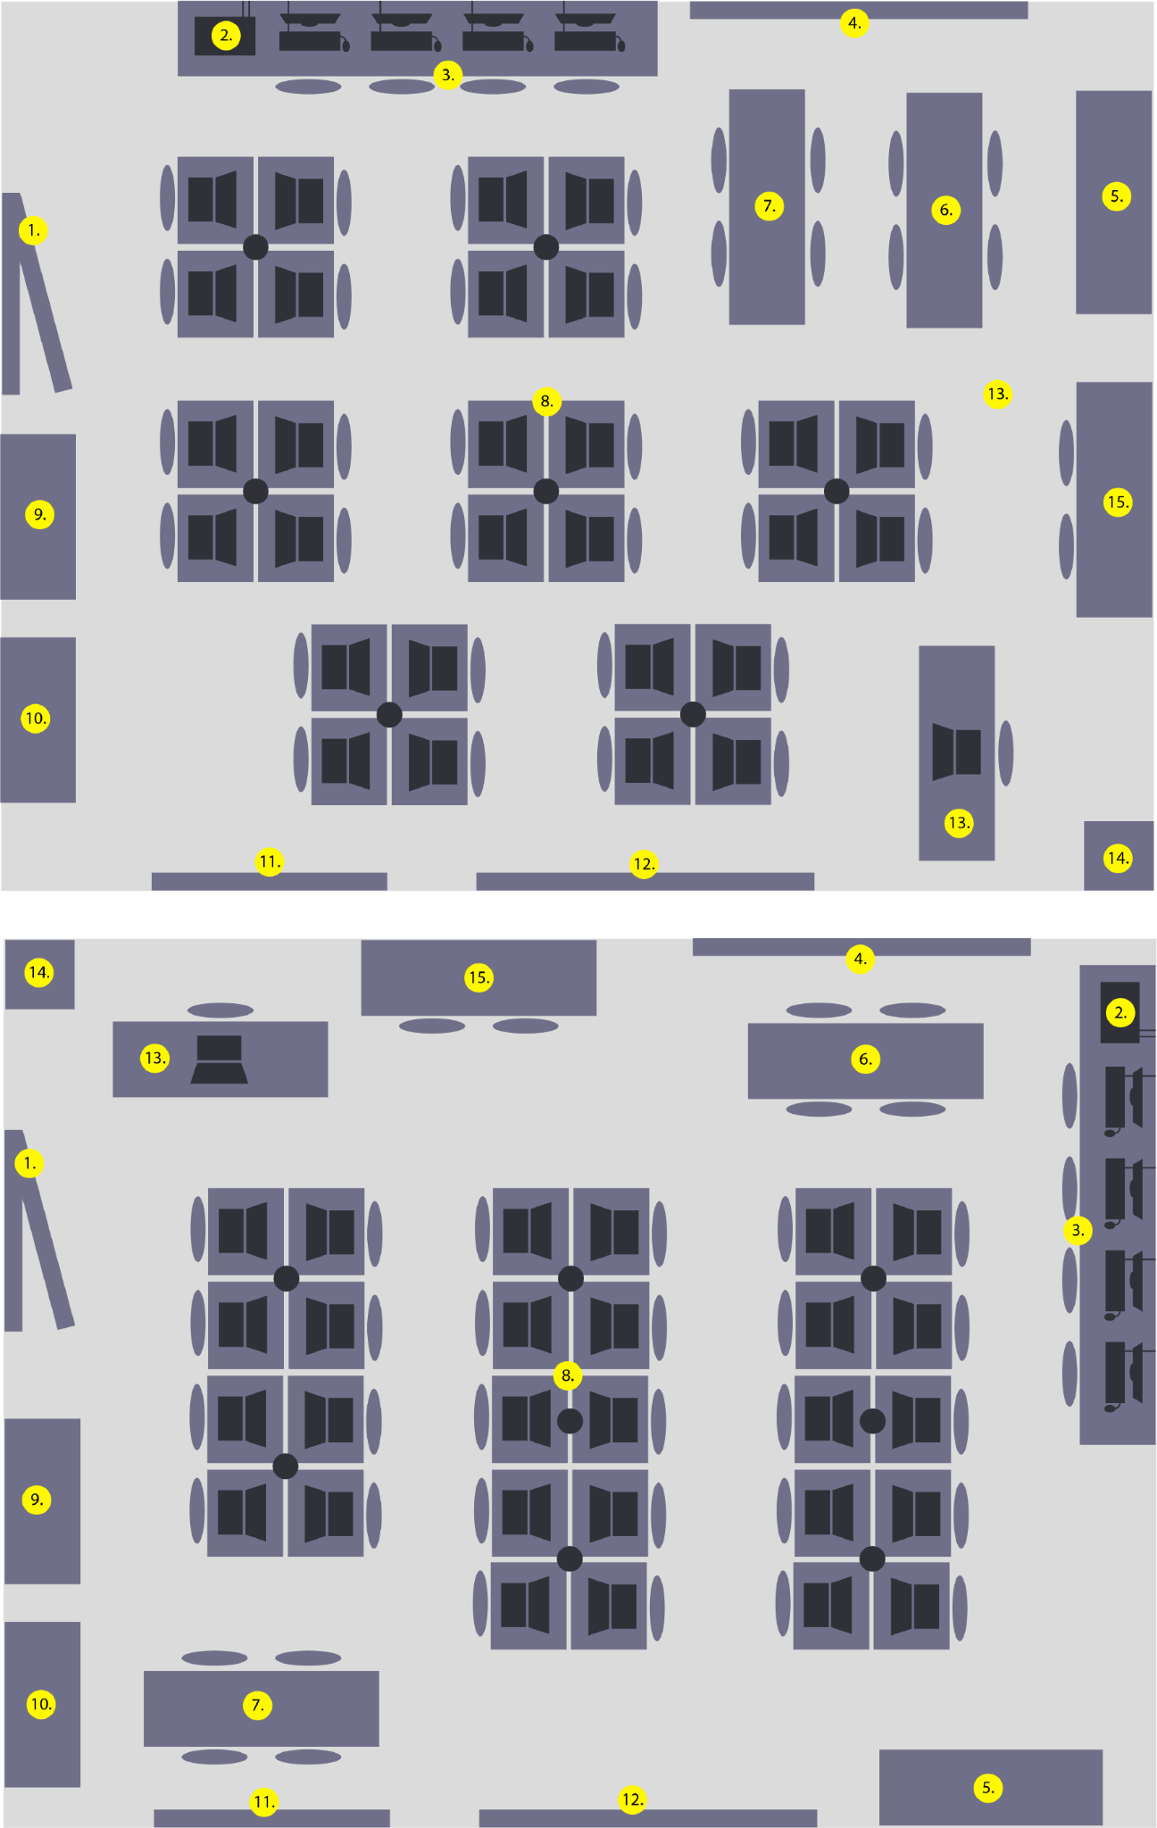
Figure 3 & 4:
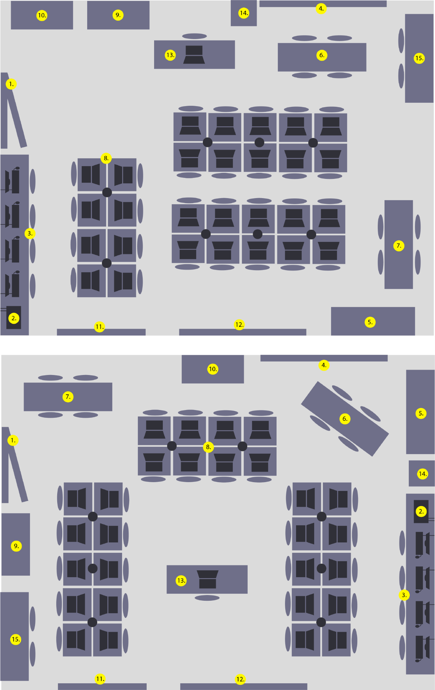
Figure 5:
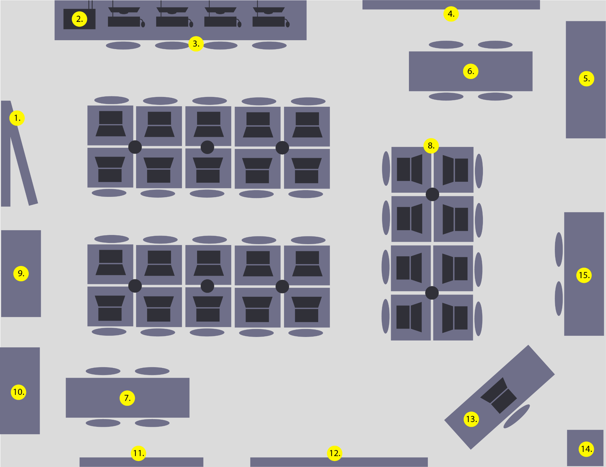
Key:
1.) Entrance 8.) Desks w/t Chromebooks & Charging Stations
2.) Printing Station 9.) Cubbies
3.) Desktop workstation 10.) Bookshelf
4.) Whiteboard 11.) Bulletin Board
5.) Metal Storage Racks where 12.) Smartboard
Oculus Devices and art supplies are stored 13.) Teacher Desk
6.) Group Table with Chairs 14.) Filing Cabinet with 4 Drawers
7.) Group Table with Chairs 15.) Teacher Workstation w/t Students
Instructional Unit Design using the Design-Plan-Act! (DPA) Model
Grade Level: 10th-12th grade Zoology
Student Demographics
- 28 total students
- Gender make-up: 17 females and 11 males
- Ethnic make-up: African American (30%), Caucasion (40%), Hispanic (20%), Other (10%)
Unit Objectives
- ZOO.8 Students will understand the structure and function of phylum Chordata, classes Amphibia and Reptilia, and how they demonstrate the characteristics of living things.
- ZOO.8.10 Dissect representative taxa and compare their internal and external anatomy and complexity.
Establishing Learning Environment
- The day before the frog dissection, learning stations will be positioned around the room that provide background information on the dissection process and expand on the previous lesson on Class Amphibia. Each group will travel with a Chromebook to complete station forms.
- Knowledge demonstration at each station will have one required and three optional tasks to allow for deeper engagement and encourage students to show greater understanding. Students must complete the 1 required task and choose one of the 3 options at each station:
  - Required: Station Summary Form (Google Forms - bit.ly link and QR code)
  - Optional: Summary in 60 seconds (students record a quick summary of what they learned using Loom on the Chrome book)
  - Optional: Canva graphic (due the next day)
  - Optional: A collage of the experience (Supplies located in the art station)
- Learning stations (4):
  - VR Lab - Dissection from a Distance
  - Computer Station - Watch two (or three) short YouTube videos with accompanying Google Form using the group assigned ChromeBook.
    - How to Dissect a Frog - 5 minutes
    - Science Lab Safety - 3 minutes
  - ChromeBooks - Teacher leads video discussions (lecture) with a guided note sheet available in Google Classroom for students to gain the necessary knowledge to complete the frog dissection on the next day.
  - Reading - Frog Dissection Packets are laminated color copies of the frog dissection and a diagram of the frog with an accompanying worksheet that will serve as the exit ticket at the end of class.
- Students will use Google Forms, station worksheets, and other materials to participate in the classroom lesson. Each station time is 10 minutes with 2 minutes for transitioning and questions.
Teaching and Learning Strategies
- Formative Assessment: The teacher will measure student understanding with a pre- and post lab assignment.
- Direct Instruction: The teacher will walk students through the dissection protocols prior to them completing it themselves. Questions will be answered and redirects will be given when necessary.
Technology
- Devices: Student chromebooks, SmartBoard, Oculus VR Headsets.
- Software: Google Forms, Google Classroom, Oculus VR Frog Dissection, Dictation Software, MicMute.
Summative Evaluation and Revision Plan
Sample Lesson
Subject: High School Zoology | Unit: Phylum Chordata
Lesson: Class Amphibia: Frog Dissection | Standards: ZOO.8, ZOO.8.10
Bell Ringer:  Students will complete a pre-lab assignment on Google Forms to assess their prior knowledge.  - What do the words dorsal and ventral mean?  - Identify the various dissection kit tools from given pictures.  - What kingdom do frogs belong to?  - What phylum do frogs belong to?  - What class do frogs belong to? | Objectives:  TSWBAT:  - Label and describe the function of the anatomical parts of a frog.  - Demonstrate proper lab safety methods.  - Demonstrate proper dissection methods.
Prepare the Lesson:
- Groups will be pre-assigned, with three groups of 6 and two groups of 5.
- Students will be put into groups based on academic ability, where two students are high performers, 2 are average performers, and 2 are low performers. The groups of 5 students will have just 1 low performer.
- The teacher will create the pre- and post- lab assignments in Google Forms.
- The teacher will check the internet connection, Oculus VR headsets, and Dissection Software to ensure the lab will run smoothly.
Learning Plan
- Formative Assessment (Pre-lab): Students will complete the pre-lab to review what they learned the day before at the learning stations, and ensure that they remember their lab safety protocols and dissection tools.
- Formative Assessment (Post-lab): Students will complete a post-lab after the dissection, in which they must label and describe the function of each anatomical part of the frog that was discovered during the dissection.
- Inquiry-Based Concept Reinforcement (Lab): As students move through the dissection, they will be required to answer questions throughout the lab protocol that guide them to understand the function of each anatomical part that they discover.
- Direct Instruction: The teacher will use the SmartBoard to display the lab protocols through a Google Slides presentation, and guide students who require additional support through the dissection. However, students have the option to proceed through the dissection on their own.
- Summative Assessment: Students will complete an exit ticket asking them to compare the anatomy of a frog to that of a reptile in compliance with the ZOO.8.10 standard.
Technology and Materials
- Student assignments in Google Forms linked through Google Classroom.
- 5 Oculus VR Headsets with accompanying Frog Dissection Software (one per group).
- Student Chromebooks, SmartBoard, Charging Stations.
- Other Software: Google Classroom, Dictation Software, MicMute, Seeing AI, Natural Reader Application.
Check for Success
The post lab and exit ticket will allow the teacher to establish if the dissection successfully developed student understanding of the anatomical functions of a frog. If less than 50% of the students in the class make below a 65% on these two evaluations, the teacher will perform a remediation lesson with an alternate dissection application.
Accommodations
- Students who require English language accommodations will be placed in groups with strong academic students who can help guide them on the requirements. They will also be given additional time to complete the pre- and post lab assignments, and allowed to complete them on paper if necessary for success.
- Dictation Software will be used for students with hearing or visual impairment.
- Gifted students will be given an additional assignment asking them to compare and contrast amphibians and reptiles on a poster chart or online presentation if time permits.
- The student groups are assigned based on academic ability to ensure all students in the group are receiving the understanding and help that they need.
Teacher Prompts
- Pre-lab and Post-lab:
  - Remind students that the pre-lab is an individual assignment and should be completed on their own within the time allotted.
  - Review student performance on the pre-lab and, if necessary, review the dissection protocols and tools prior to completing the dissection.
- Dissection:
  - Remind students to work together efficiently, and redirect when necessary.
- Exit Evaluation:
  - Grade exit evaluation after class and determine if reteaching is necessary.

